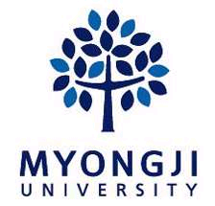 | 2021 Summer  MJU Online Exchange Program

3cm×4cm  upload your photo here  (color only) | Name | (in the order as appeared in passport)
 | You are | ( ) University
 | Gender
 | E-mail
SNS ID  (Choose the most frequently used one) |  | kakao ID: | line ID:
 |  | wechat ID: | others(please specify) ID:
Mother tongue |  | Japanese
How long have you studied Korean?  (“√”) |  | ( ) 3 months ~ 6 months | ( ) less than 1 year
 |  | ( ) 1~3 years | ( ) More than 3 years
Why do you want to apply for this program and what do you want to learn through this opportunity?
I, hereby, declare my participation in MJU Language Exchange Program. I understand my responsibilities and will comply with the program conditions.

2021. . .
Name : (signature)

