Form for “Gandai Hyakkei”
100 places of memories at Iwate University campus

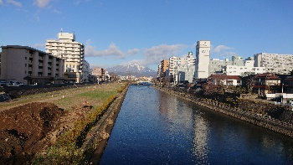
That day, that time, that place, in Iwate University.
Please share your important memorable scene on the Iwate University campus along with a special story. Photos are also welcome. If you do not have a photo, the staff at the International Office of Iwate University will take it. Please let us know if you would like us to provide a picture.

Name
Country
Faculty/Graduated School
Memorable place in Iwate University (or Morioka city)
Story
(JP: 500 words
EN: 250 words)

Please attach the picture data. (Jpeg, etc.)
Send to：iuic@iwate-u.ac.jp (International Office, Iwate University)

Posting rules
- We may make corrections.
- The copyright of the published manuscript belongs to Iwate University.
- If personally identifiable information is included, we may edit the information.
- Posts may be published on the Iwate University International Exchange website, official Social medias, public relations magazines, etc. in addition to Gandai’s Sakkora News.

Gandai Hyakkei Relay
Please kindly introduce this " Gandai Hyakkei " to your friends who are graduates of Iwate University and ask them to write their story. We would appreciate it if you could provide us with their contact information as well. Thank you for your cooperation!

⌒*⌒Names and contacts of friends and acquaintances introduced by you⌒*⌒*⌒*
Name:

E-mail address:
⌒*⌒*⌒*⌒*⌒*⌒*⌒*⌒*⌒*⌒*⌒*⌒*⌒*⌒*⌒*⌒*⌒*⌒*⌒*⌒*⌒*

Thank you!

