Thursday, December 2nd 7pm (ET) using Zoom (In Japan, 12/3 9am, JST)
https://iu.zoom.us/j/87853103438
A special zoom lecture on domestic cats
Host: Spackled
Reiko Uenoyama and Masao Miyazaki
Iwate University, JAPAN
mmasao@iwate-u.ac.jp

The characteristic response of domestic cats to plant iridoids allows them to gain chemical defense against mosquitoes
Domestic cats (Felis silvestris catus) and other felids rub their faces and heads against catnip (Nepeta cataria) and silver vine (Actinidia polygama) and roll on the ground as a characteristic response. While this response is well known, its biological significance and underlying mechanism remain undetermined. In this seminar, we report the neurophysiological mechanism and functional significance of this feline response. We isolated the iridoid nepetalactol from silver vine leaves, which elicits the response in cats and other felids. Using synthesized nepetalactol, we have demonstrated that the μ-opioid system regulating euphoric and rewarding effects in humans is involved in the expression of the silver vine response in cats. Most importantly, we have uncovered an adaptive benefit of the behavioral response in cats: rubbing and rolling on the leaves of silver vine transfers nepetalactol to the heads, faces, and bodies of cats. As a consequence, this reduces the number of Ae. albopictus mosquitoes that land on the animal’s head, helping to protect from mosquito bites. In conclusion, the characteristic response of cats to nepetalactol via the μ-opioid system provides an important example of chemical pest defense using plant metabolites in non-human mammals. These findings provide new insight into this plant-induced feline response, for which the biological significance was first questioned in popular science culture more than 300 years ago.

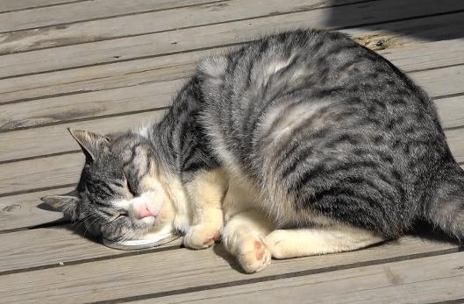
Nepetalactol elicits the characteristic rubbing response to domestic cats.

